Confusion Matrix
A confusion matrix is a table that allows visualization and calculation of a classification model's performance. It summarizes the number of correct and incorrect predictions made by the model, categorized by the actual and predicted classes.

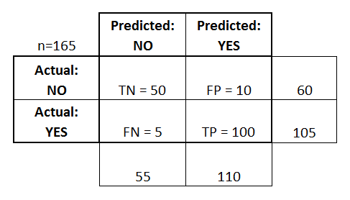

Here's a breakdown with an example:
Scenario: Imagine a model is designed to detect spam emails. A confusion matrix can help assess its accuracy.
Example:
Let's say the model processed 200 emails, and this is the confusion matrix:
 | Predicted Spam | Predicted Not Spam
Actual Spam | 80 (True Positive) | 20 (False Negative)
Actual Not Spam | 10 (False Positive) | 90 (True Negative)
Explanation of Terms:
- True Positive (TP):
The model correctly predicted "Spam" when the email was actually spam. (80)
- False Negative (FN):
The model incorrectly predicted "Not Spam" when the email was actually spam. (20)
- False Positive (FP):
The model incorrectly predicted "Spam" when the email was actually not spam. (10)
- True Negative (TN):
The model correctly predicted "Not Spam" when the email was actually not spam. (90)
Calculations from the Confusion Matrix:
- Accuracy:
(TP + TN) / Total = (80 + 90) / 200 = 0.85 or 85%. This means the model correctly classified 85% of the emails.
- Precision:
TP / (TP + FP) = 80 / (80 + 10) = 0.88 or 88%. This means when the model predicted "Spam," it was correct 88% of the time.
- Recall (Sensitivity):
TP / (TP + FN) = 80 / (80 + 20) = 0.80 or 80%. This means the model identified 80% of the actual spam emails.
- Specificity:
TN / (TN + FP) = 90 / (90 + 10) = 0.90 or 90%. This means the model correctly identified 90% of the non-spam emails.

